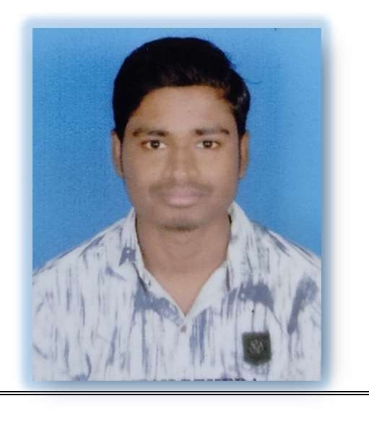

**Ganesh Behera**

**Bachelor Of Technology (Civil) AT/PO- Mundamarai, Ganjam STATE- Odisha, PIN-761114 Contact No.: +91 8342970031**

**E-mail:** [ganeshjspider@gmail.com](mailto:ganeshjspider@gmail.com)

# CAREER OBJECTIVE

Looking forward to find a responsible and challenging position in an innovative organisation, where I can utilize my skills and knowledge which would enable me a fresh graduate to grow and excel along with the company by learning new technologies and contribute positively to the growth of the organization as well as my personal growth.

# ACADEMIC CAREER

|  |  |  |  |
| --- | --- | --- | --- |
| **QUALIFICATION** | **BOARD/INSTITUTION** | **YEAR** | **PERCENTAGE %** |
| Bachelor Of  Technology(B.Tech) | Kalam Institute of Technology,  Berhampur (Under BPUT) | 2016-2019 | 7.15 CGPA |
| Diploma In Civil | Kalam Institute of Technology,  (Under SCTE & VT, Odisha) | 2014-2016 | 72% |
| Intermediate (+2 Science) | CHSE, Odisha Somanath Science College,  Mundamarai, Ganjam | 2012- 2014 | 47.5% |
| HSC (10th) | BSE, Odisha  Ananta Narayan Bidyapitha, Mundamarai, Ganjam | 2012 | 69% |

**MANUAL TESTING**

* Good knowledge in all the phases of **SDLC and STLC.**
* Adroit to perform Functional Testing like **Functionality,Integration, System, Acceptance, Smoke, Adhoc ,Regression & Compatibility Testing.**
* Adequate knowledge on **Non-Functional Testing** like **Performance & Usability Testing,**
* Well known in various Test Case Design Techniques like **Error Guessing, Equivalence Partition and Boundary Value Analysis**.
* Good Knowledge in Writing, Reviewing & Executing Test case.
* Good knowledge on Defect **Life Cycle**.

# INTERPERSONAL SKILL

* Good communication skill.
* Self-motivated and Hardworking.
* Positive Approach and Promoting Teamwork
* Ability to cope up with different situations.
* Sincere, Confident and Determined

# PERSONAL PROFILE

* Father’s Name : Mr. Simanchal Behera
* Mother’s Name : Mrs. Rina Behera
* Date of Birth : 07th March,1997
* Language Known : English, Hindi and Odia.
* Nationality/Religion : Indian/Hindu
* Interest & Hobbies : Watching & Playing cricket, Travelling.
* Address : At/Po: Mundamarai, Dist.: Ganjam, Pin-761114 (Odisha)

# DECLARATION

I do hereby declare that the above information is correct and true to the best of my knowledge and belief.

**Place**: Mundamarai, Odisha Ganesh Behera

**Date**: 15th June,2022 **Signature of Applicant**